**PHASE 2 - Org Setup & Configuration**

**Company Profile Setup**

Basic org details are configured under **Setup → Company Information → Edit** to establish the foundational settings for the QuickServe org.

* **Name**: QuickServe Management System
* **Time Zone**: GMT+05:30 Asia/Kolkata
* **Locale**: English (India)
* **Language**: English
* **Currency**: INR

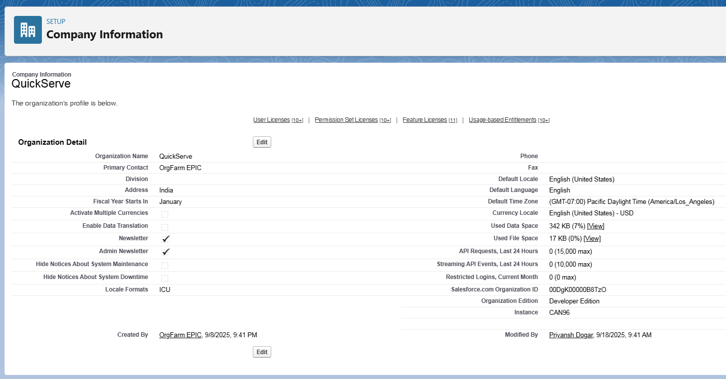

**Business Hours Setup**

Working hours are configured to reflect restaurant operating times for future case management and SLA tracking.

* **Path**: Setup → Business Hours → New.
* **Name**: Standard Restaurant Hours.
* **Time Zone**: GMT+05:30 Asia/Kolkata.
* **Working Hours**: Mon-Sun 10:00 AM–10:00 PM.

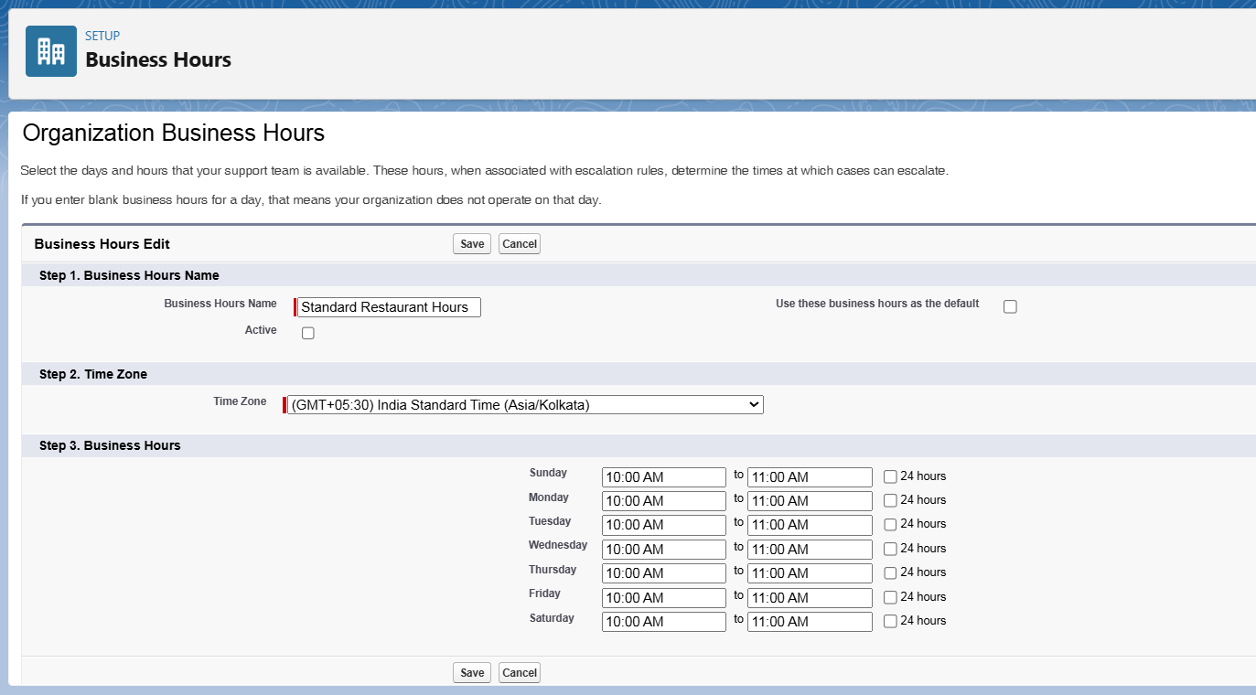

**Fiscal Year Setup**

A standard fiscal year is established to define reporting periods for sales and order analysis.

* **Path**: Setup → Fiscal Year.
* **Type**: Standard Fiscal Year.
* **Configuration**: The starting month is set to **January**.

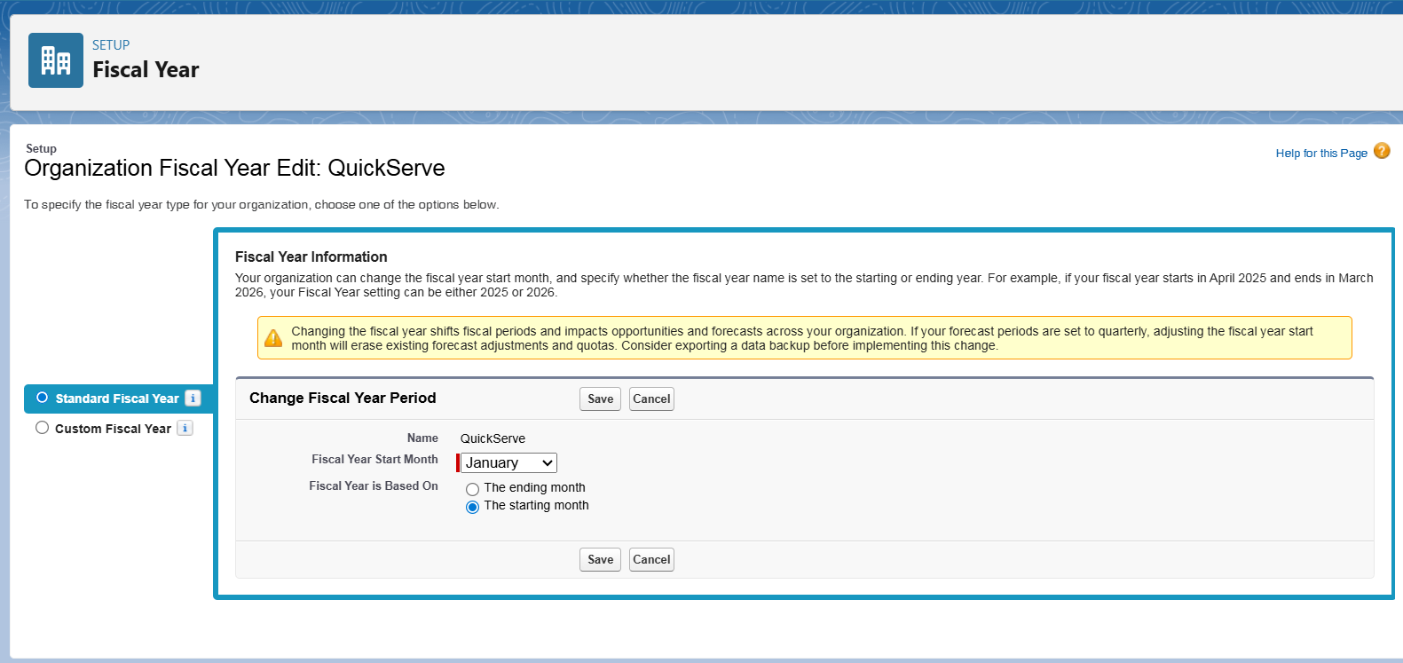

**User Setup (Profiles, Roles, Permission Sets, Users)**

* **Profiles**: Custom profiles were created by cloning standard profiles to provide baseline access.
  + **Restaurant_Staff_Profile**: For daily order entry and customer interaction.

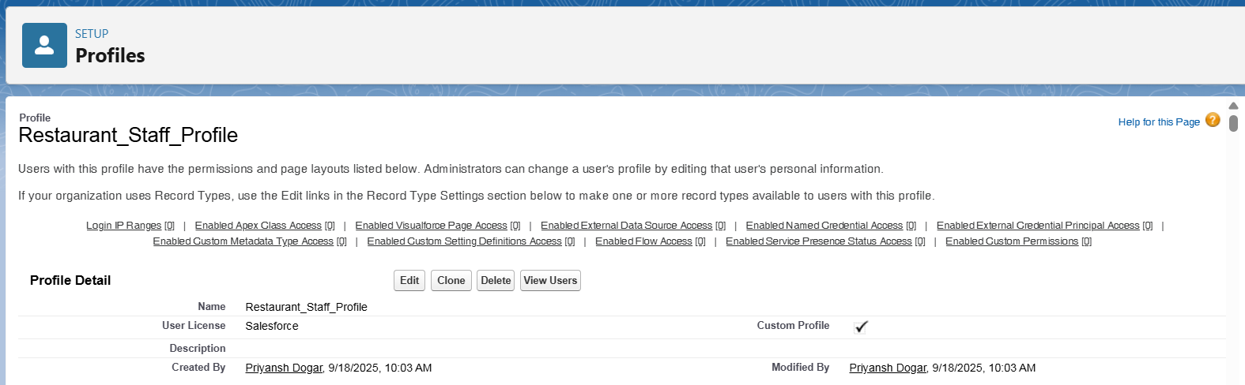

* + **Manager_Profile**: For operational oversight, reporting, and manual adjustments.

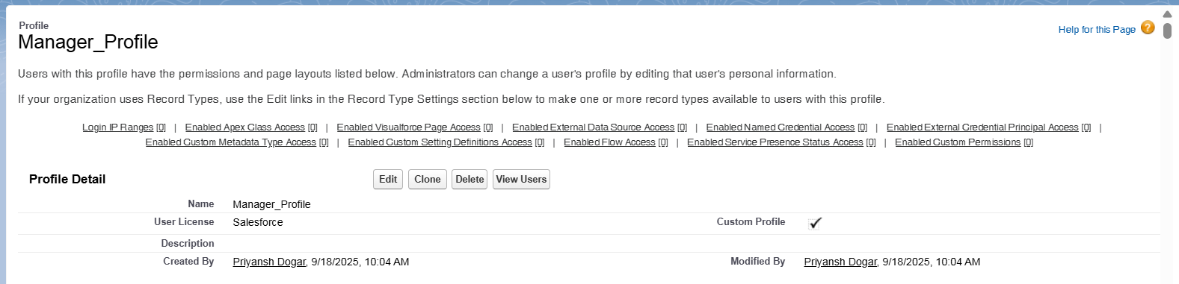

* **Roles**: A role hierarchy was defined for data visibility and report roll-ups.
  + Manager, Restaurant Staff.
* **Permission Sets**: A permission set was created for special actions.
  + **Manual_Points_Adjust_PS**: Grants access to modify loyalty points, assigned only to Managers.
* **Users**: Sample users were created and assigned the appropriate profiles and roles.
  + **staff1** → Restaurant_Staff_Profile, Role: Restaurant Staff

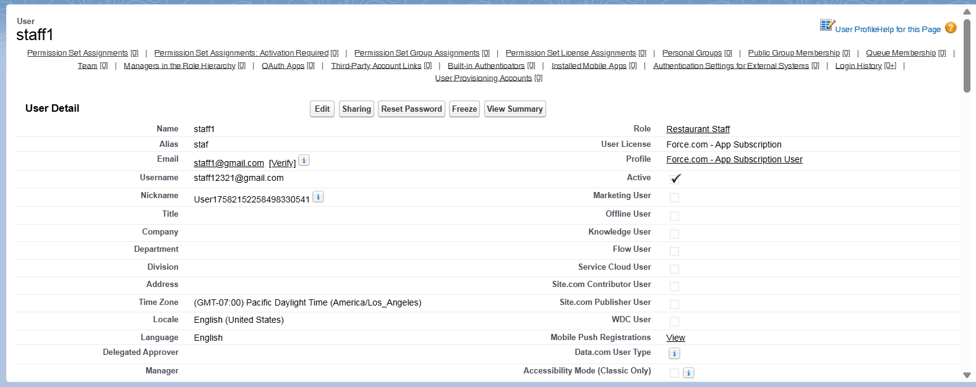

* + **manager1** → Manager_Profile, Role: Manager

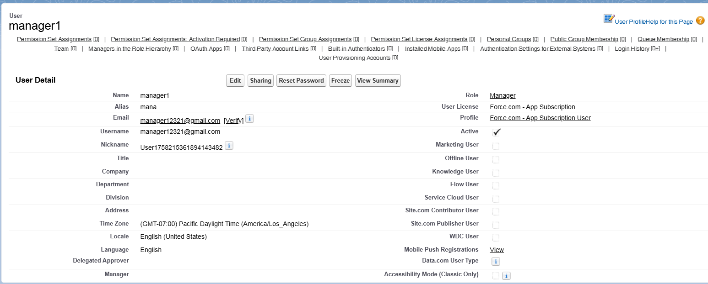

**Role Hierarchy Setup**

The hierarchy defines the data access and reporting structure within the organization.

* **Path**: Setup → Roles → Set Up Roles.
* **Top-Level Role**: CEO.
* **Manager Role**: Added as a child of the CEO.
* **Restaurant Staff Role**: Added as a child under the Manager.
* **Resulting Hierarchy**: CEO → Manager → Restaurant Staff

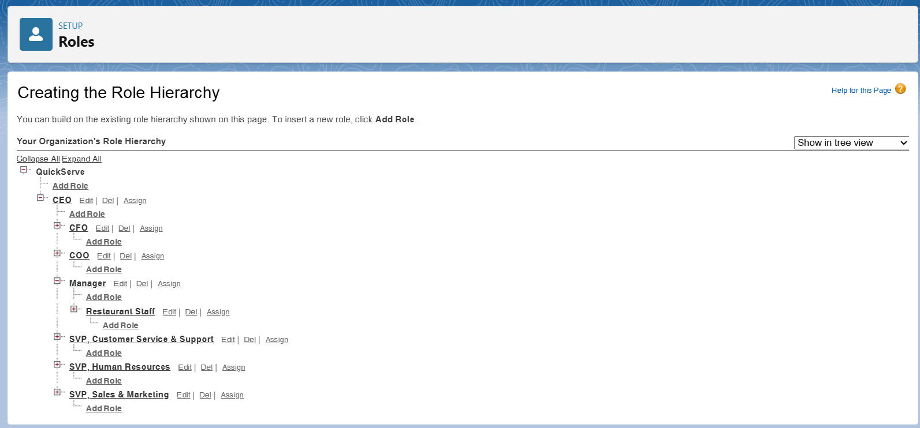

**OWD & Sharing Rules**

* **OWD (Org-Wide Default)**: This will be configured in Phase 3, as the settings need to be applied to the custom objects that will be created then.
* **Sharing Rule**: This will also be implemented in Phase 3 after the custom objects and OWD settings are in place.

**Dev Org Setup**

The development environment was prepared to support the project implementation.

* A Salesforce **Developer Edition org** was set up to build the project.
* A **GitHub Repository** was created for version control of the source code.
* **VS Code and SFDX** were configured for developing the Apex backend and future Lightning Web Components.